   



 



SIM800C_Hardware_Design_V1.02

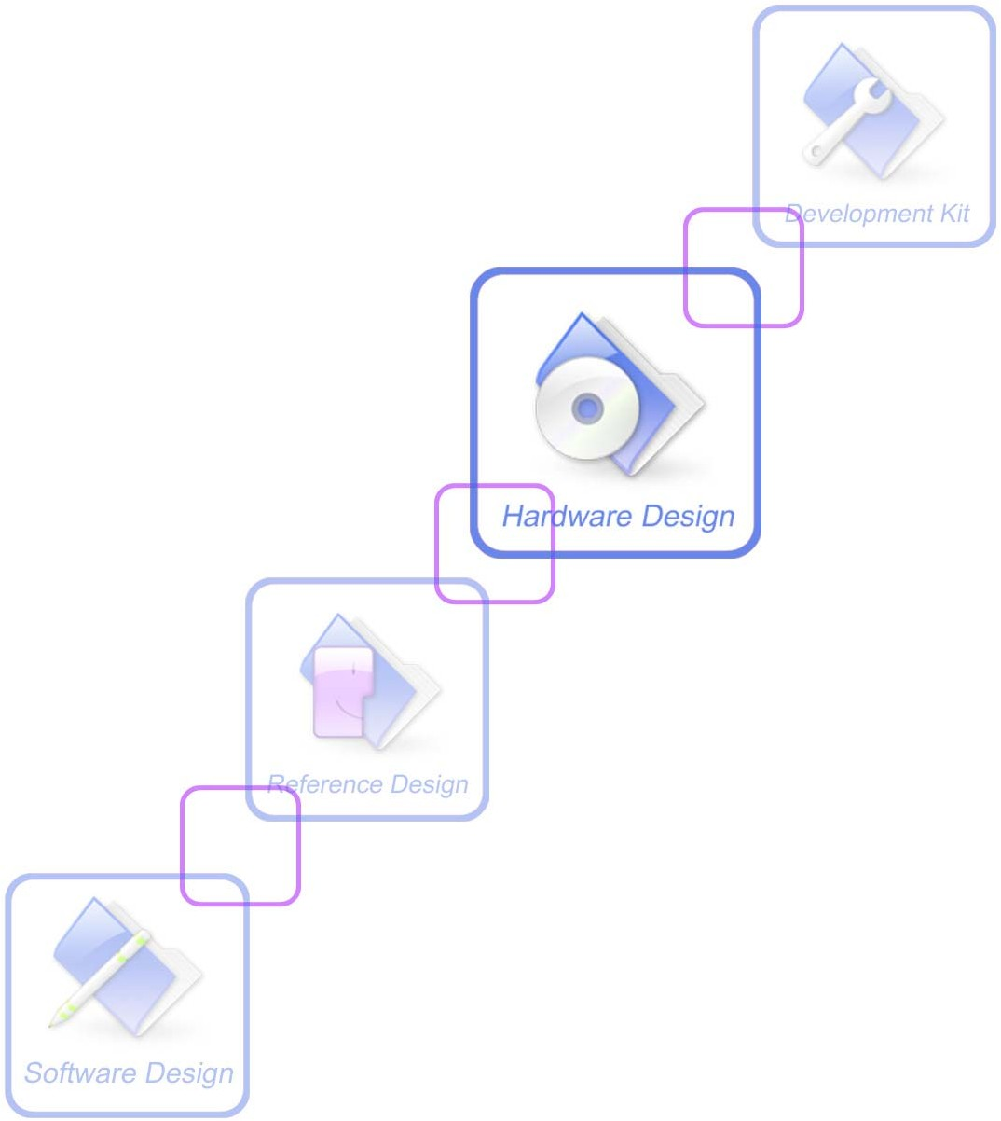

|  |  |
| --- | --- |
| **Document Title** | SIM800C Hardware Design |
| **Version** | V1.02 |
| **Date** | 2015-04-27 |
| **Status** | Release |
| **Document Control ID** | SIM800C_Hardware_Design_V1.02 |

**General Notes**



SIMCom offers this information as a service to its customers, to support application and engineering efforts that use the products designed by SIMCom. The information provided is based upon requirements specifically provided to SIMCom by the customers. SIMCom has not undertaken any independent search for additional relevant information, including any information that may be in the customer’s possession. Furthermore, system validation of this product designed by SIMCom within a larger electronic system remains the responsibility of the customer or the customer’s system integrator. All specifications supplied herein are subject to change.

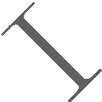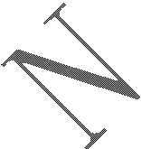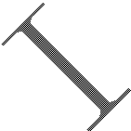

**Copyright**

This document contains proprietary technical information which is the property of SIMCom Limited, copying of this document and giving it to others and the using or communication of the contents thereof, are forbidden without express authority. Offenders are liable to the payment of damages. All rights reserved in the event of grant of a patent or the registration of a utility model or design. All specification supplied herein are subject to change without notice at any time.

***Copyright © Shanghai SIMCom Wireless Solutions Ltd. 2015***

# Contents

Version History 8

1. Introduction 9
2. SIM800C Overview 9

2.1. SIM800C 9

* 1. SIM800C Key Features 9

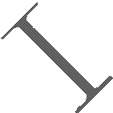

* 1. Operating Mode 11
  2. Functional Diagram. 12

1. Package Information 13
   1. Pin Out Diagram 13

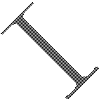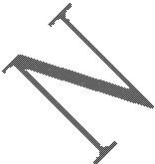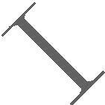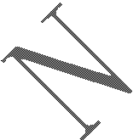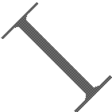

* 1. Pin Description 13
  2. Package Dimensions 15

1. Application Interface 17
   1. Power Supply 17
      1. Power Supply Pin 18
      2. Monitoring Power Supply 19
   2. Power on/off SIM800C 19
      1. Power on SIM800C 19
      2. Power off SIM800C 20
   3. Power Saving Mode 22
      1. Minimum Functionality Mode 22
      2. Sleep Mode 1 (AT+CSCLK=1) 22
      3. Wake Up SIM800C from Sleep Mode 1 23
      4. Sleep Mode 2 (AT+CSCLK=2) 23
      5. Wake Up SIM800C from Sleep Mode 2 23
   4. Power Saving Mode 23
   5. Serial Port and USB Interface 24
      1. Function of Serial Port 25
      2. Serial Interfaces 25
      3. Debug Interface 27
      4. Software Upgrade. 28
   6. UART1_RI Behaviors 28
   7. Audio Interfaces 29
      1. Speaker Interfaces Configuration 30
      2. Microphone Interfaces Configuration 30
      3. Audio Electronic Characteristic 30
      4. TDD 31
   8. SIM Card Interface. 31
      1. SIM Card Application 31
      2. SIM Card Design Guide 32
      3. Design Considerations for SIM Card Holder 32
   9. ADC 34
   10. Network Status Indication 35
       1. NETLIGHT Multiplexing Function 35
   11. Operating Status Indication 36
       1. STATUS Multiplexing Function 36
   12. RF Synchronization Signal 36
       1. RF_SYNC Multiplexing Function 36
   13. Antenna Interface 37
       1. GSM Antenna Interface 37



* + 1. Bluetooth Antenna Interface 38

1. PCB Layout 39
   1. Pin Assignment 39
   2. Principle of PCB Layout 39

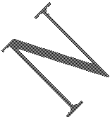

* + 1. Antenna Interface 40
    2. Power Supply 40
    3. SIM Card Interface 40
    4. Audio Interface 40
    5. Others 40

1. Electrical, Reliability and Radio Characteristics 41
   1. Absolute Maximum Ratings 41
   2. Recommended Operating Conditions 41
   3. Digital Interface Characteristics. 41
   4. SIM Card Interface Characteristics 41
   5. SIM_VDD Characteristics 42
   6. VDD_EXT Characteristics 42
   7. VRTC Characteristics 42
   8. Current Consumption (VBAT=4.0V) 42
   9. Electro-Static Discharge 43
   10. Radio Characteristics 44
       1. Module RF Output Power 44
       2. Module RF Receive Sensitivity 45
       3. Module Operating Frequencies 45
2. Manufacturing 46
   1. Top and Bottom View of SIM800C 46
   2. Typical Solder Reflow Profile 46
   3. The Moisture Sensitivity Level 47
   4. Baking Requirements 47
3. Appendix 48
4. Related Documents 48
5. Multiplexing Function 49
6. Terms and Abbreviations 49

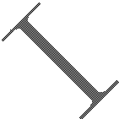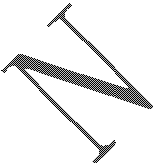

1. Safety Caution 51

**Table Index**

TABLE 1: MODULE INFORMATION 9

TABLE 2: SIM800C KEY FEATURES 9

TABLE 3: CODING SCHEMES AND MAXIMUM NET DATA RATES OVER AIR INTERFACE 11

TABLE 4: OVERVIEW OF OPERATING MODES 11

TABLE 5: PIN DESCRIPTION 13

TABLE 6: RECOMMENDED ZENER DIODE 17

TABLE 7: THE CURRENT CONSUMPTION OF FUNCTION MODE 22

TABLE 8: SERIAL PORT AND USB PIN DEFINITION 24

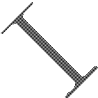

TABLE 9: SERIAL PORT CHARACTERISTICS 25

TABLE 10: USB_VBUS OPERATION VOLTAGE 27

TABLE 11: RI BEHAVIORS 28

TABLE 12: AUDIO INTERFACE DEFINITION 29

TABLE 13: MICROPHONE INPUT CHARACTERISTICS 30

TABLE 14: AUDIO OUTPUT CHARACTERISTICS 31

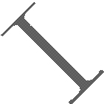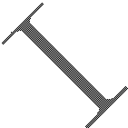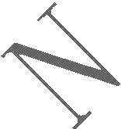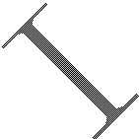

TABLE 15: SIM PIN DEFINITION 31

TABLE 16: PIN DESCRIPTION (MOLEX SIM CARD HOLDER) 33

TABLE 17: PIN DESCRIPTION (AMPHENOL SIM CARD HOLDER) 34

TABLE 18: PIN DEFINITION OF THE ADC 34

TABLE 19: ADC SPECIFICATION 35

TABLE 20: PIN DEFINITION OF THE NETLIGHT 35

TABLE 21: STATUS OF THE NETLIGHT PIN 35

TABLE 22: NETLIGHT MULTIPLEXING FUNCTION 35

TABLE 23: PIN DEFINITION OF THE STATUS 36

TABLE 24: STATUS MULTIPLEXING FUNCTION 36

TABLE 25: DEFINITION OF THE RF_SYNC PIN 36

TABLE 26: RF_SYNC MULTIPLEXING FUNCTION 36

TABLE 27: ABSOLUTE MAXIMUM RATINGS 41

TABLE 28: RECOMMENDED OPERATING CONDITIONS 41

TABLE 29: DIGITAL INTERFACE CHARACTERISTICS 41

TABLE 30: SIM CARD INTERFACE CHARACTERISTICS 41

TABLE 31: SIM_VDD CHARACTERISTICS 42

TABLE 32: VDD_EXT CHARACTERISTICS 42

TABLE 33: VRTC CHARACTERISTICS 42

TABLE 34: CURRENT CONSUMPTION 42

TABLE 35: THE ESD CHARACTERISTICS (TEMPERATURE: 25℃, HUMIDITY: 45 %) 43

TABLE 36: GSM850 AND EGSM900 CONDUCTED RF OUTPUT POWER 44

TABLE 37: DCS1800 AND PCS1900 CONDUCTED RF OUTPUT POWER 44

TABLE 38: CONDUCTED RF RECEIVE SENSITIVITY 45

TABLE 39: OPERATING FREQUENCIES 45

TABLE 40: MOISTURE SENSITIVITY LEVEL AND FLOOR LIFE 47

TABLE 41: BAKING REQUIREMENTS 47

TABLE 42: RELATED DOCUMENTS 48

TABLE 43: MULTIPLEXING FUNCTION 49

TABLE 44: TERMS AND ABBREVIATIONS 49

TABLE 45: SAFETY CAUTION 51

# Figure Index

FIGURE 1: SIM800C FUNCTIONAL DIAGRAM 12

FIGURE 2: PIN OUT DIAGRAM (TOP VIEW) 13

FIGURE 3: DIMENSIONS OF SIM800C (UNIT: MM) 15

FIGURE 4: RECOMMENDED PCB FOOTPRINT OUTLINE (UNIT: MM) 16

FIGURE 5: REFERENCE CIRCUIT OF THE VBAT INPUT. 17

FIGURE 6: REFERENCE CIRCUIT OF THE LDO POWER SUPPLY 17

FIGURE 7: REFERENCE CIRCUIT OF THE DC-DC POWER SUPPLY 18

FIGURE 8: VBAT VOLTAGE DROP DURING TRANSMIT BURST 18

FIGURE 9: THE MINIMAL VBAT VOLTAGE REQUIREMENT AT VBAT DROP 18

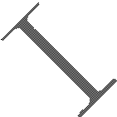

FIGURE 10: POWERED ON/DOWN MODULE USING TRANSISTOR 19

FIGURE 11: POWERED ON/DOWN MODULE USING BUTTON 19

FIGURE 12: TIMING OF POWER ON MODULE 19

FIGURE 13: TIMING OF POWER OFF SIM800C BY PWRKEY 20

FIGURE 14: TIMING OF RESTART SIM800C 22

FIGURE 15: RTC SUPPLY FROM CAPACITOR 23

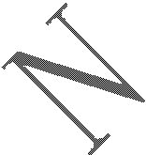

FIGURE 16: RTC SUPPLY FROM NON-CHARGEABLE BATTERY 24

FIGURE 17: RTC SUPPLY FROM RECHARGEABLE BATTERY 24

FIGURE 18: CONNECTION OF THE SERIAL INTERFACES 26

FIGURE 19: RESISTOR MATCHING CIRCUIT 26

FIGURE 20 : DIODE ISOLATION CIRCUIT 26

FIGURE 21: TX LEVEL MATCHING CIRCUIT 27

FIGURE 22: RX LEVEL MATCHING CIRCUIT 27

FIGURE 23: USB REFERENCE CIRCUIT 27

FIGURE 24: CONNECTION FOR SOFTWARE UPGRADING AND DEBUGGING 28

FIGURE 25: UART1_RI BEHAVIOUR OF VOICE CALLING AS A RECEIVER 29

FIGURE 26: UART1_RI BEHAVIOUR OF URC OR RECEIVE SMS 29

FIGURE 27: UART1_RI BEHAVIOUR AS A CALLER 29

FIGURE 28: SPEAKER REFERENCE CIRCUIT 30

FIGURE 29: MICROPHONE REFERENCE CIRCUIT 30

FIGURE 30: REFERENCE CIRCUIT OF THE 8-PIN SIM CARD HOLDER 32

FIGURE 31: REFERENCE CIRCUIT OF THE 6-PIN SIM CARD HOLDER 32

FIGURE 32: MOLEX 91228 SIM CARD HOLDER 33

FIGURE 33: AMPHENOL C707 10M006 512 SIM CARD HOLDER 34

FIGURE 34: REFERENCE CIRCUIT OF NETLIGHT 35

FIGURE 35: RF_SYNC SIGNAL DURING TRANSMIT BURST 36

FIGURE 36: GSM ANTENNA MATCHING CIRCUIT 37

FIGURE 37: GSM ANTENNA MATCHING CIRCUIT WITHOUT RF CONNECTOR 37

FIGURE 38: BLUETOOTH ANTENNA MATCHING CIRCUIT 38

FIGURE 39: PIN ASSIGNMENT 39

FIGURE 40: TOP AND BOTTOM VIEW OF SIM800C 46

FIGURE 41: TYPICAL SOLDER REFLOW PROFILE OF LEAD-FREE PROCESSES 46

# Version History

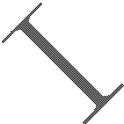

|  |  |  |  |
| --- | --- | --- | --- |
| **Date** | **Version** | **Description of change** | **Author** |
| 2014-11-06 | 1.00 | Origin | Yanwu.wang;  Xiaobo.bai |
| 2015-01-06 | 1.01 | Update figure1,figure12,figure40 Delete figure26  Add VRTC segment to table5  Update table11,table34,table35,table36 | Yanwu.wang; Xiaobo.bai |
| 2015-04-27 | 1.02 | Update figure7,figure10,figure11,figure10,figure12,figure13, figure14,figure23,figure37,figure38  Update table1,table2 | Yanwu.wang; Xiaobo.bai |

# Introduction

This document describes SIM800C hardware interface in great detail. The document can help customer to quickly understand SIM800C interface specifications, electrical and mechanical details. With the help of this document and other SIM800C application notes, customer guide, customers can use SIM800C to design various applications quickly.

# SIM800C Overview

SIM800C is a quad-band GSM/GPRS module that works on frequencies GSM850MHz, EGSM900MHz, DCS1800MHz and PCS1900MHz. SIM800C features GPRS multi-slot class10/class12 (optional) and supports the GPRS coding schemes CS-1, CS-2, CS-3 and CS-4.

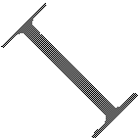

With a tiny configuration of 17.6*15.7*2.3mm, SIM800C can meet almost all the space requirements in customers’ applications, such as smart phone, PDA and other mobile devices.

SIM800C is a SMT package with 42 pads, and provides all hardware interfaces between the module and customers’ boards.

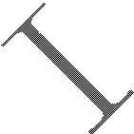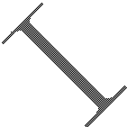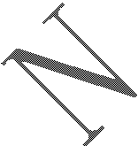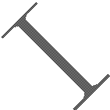

* + One 3 lines serial port and one full modem serial port;
  + One USB, the USB interface can debug, download software;
  + One audio channel which include a microphone input and a speaker output;
  + Programmable general purpose input and output;
  + One SIM card interface;
  + Support Bluetooth (need software support).

SIM800C is designed with power saving technique so that the current consumption is as low as 0.6mA in sleep mode.

### SIM800C

**Table 1: Module information**

|  |  |
| --- | --- |
|  | **SIM800C** |
| GSM | 850,900,1800 and 1900MHz |
| BT | (need software support) |
| FLASH | SIM800C (24Mbit)  SIM800C32 (32Mbit) |
| RAM | 32Mbit |

### SIM800C Key Features

#### Table 2: SIM800C key features

|  |  |
| --- | --- |
| **Feature** | **Implementation** |
| Power supply | 3.4V ~4.4V |
| Power saving | Typical power consumption in sleep mode is 0.88mA (BS-PA-MFRMS=9 ) |
| Frequency bands | * Quad-band: GSM 850, EGSM 900, DCS 1800, PCS 1900. SIM800C can |

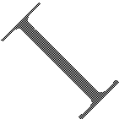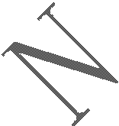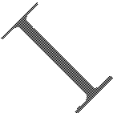

|  |  |
| --- | --- |
|  | search the 4 frequency bands automatically. The frequency bands can also be set by AT command “AT+CBAND”. For details, please refer to ***document [1]***.   * Compliant to GSM Phase 2/2+ |
| Transmitting power | * Class 4 (2W) at GSM 850 and EGSM 900 * Class 1 (1W) at DCS 1800 and PCS 1900 |
| GPRS connectivity | * GPRS multi-slot class 12（default） * GPRS multi-slot class 1~12 (option) |
| Temperature range | * Normal operation: -40°C ~ +85°C * Storage temperature -45°C ~ +90°C |
| Data GPRS | * GPRS data downlink transfer: max. 85.6 kbps * GPRS data uplink transfer: max. 85.6 kbps * Coding scheme: CS-1, CS-2, CS-3 and CS-4 * PAP protocol for PPP connect * Integrate the TCP/IP protocol. * Support Packet Broadcast Control Channel (PBCCH) |
| USSD | * Unstructured Supplementary Services Data (USSD) support |
| SMS | * MT, MO, CB, Text and PDU mode * SMS storage: SIM card |
| SIM interface | Support SIM card: 1.8V, 3V |
| External antenna | Antenna pad |
| Audio features | Speech codec modes:   * Half Rate (ETS 06.20) * Full Rate (ETS 06.10) * Enhanced Full Rate (ETS 06.50 / 06.60 / 06.80) * Adaptive multi rate (AMR) * Echo Cancellation * Noise Suppression |
| Serial port and USB port | **Serial port:**   * Default one Full modem serial port * Can be used for AT commands or data stream * Support RTS/CTS hardware handshake and software ON/OFF flow control * Multiplex ability according to GSM 07.10 Multiplexer Protocol * Autobauding supports baud rate from 1200 bps to 115200bps * upgrading firmware   **USB port:**   * USB_DN and USB_DP * Can be used for debugging and upgrading firmware |
| Phonebook management | Support phonebook types: SM, FD, LD, RC, ON, MC |
| SIM application toolkit | GSM 11.14 Release 99 |
| Physical characteristics | Size:17.6*15.7*2.3mm  Weight:1.3g |
| Firmware upgrade | Full modern serial port or USB port(recommend to use USB port) |

**Table 3: Coding schemes and maximum net data rates over air interface**

|  |  |  |  |
| --- | --- | --- | --- |
| **Coding scheme** | **1 timeslot** | **2 timeslot** | **4 timeslot** |
| CS-1 | 9.05kbps | 18.1kbps | 36.2kbps |
| CS-2 | 13.4kbps | 26.8kbps | 53.6kbps |
| CS-3 | 15.6kbps | 31.2kbps | 62.4kbps |
| CS-4 | 21.4kbps | 42.8kbps | 85.6kbps |

### Operating Mode

The table below summarizes the various operating modes of SIM800C.



**Table 4: Overview of operating modes**



|  |  |  |
| --- | --- | --- |
| **Mode** | **Function** | |
| Normal operation | GSM/GPRS SLEEP | Module will automatically go into sleep mode if the conditions of sleep mode are enabling and there aren’t on air and hardware interrupt (such as GPIO interrupt or data on serial port).  In this case, the current consumption of module will reduce to the minimal level.  In sleep mode, the module can still receive paging message and SMS. |
| GSM  IDLE | Software is active. Module is registered to the GSM network, and the  module is ready to communicate. |
| GSM TALK | Connection between two subscribers is in progress. In this case, the power  consumption depends on network settings such as DTX off/on, FR/EFR/HR, hopping sequences, antenna. |
| GPRS STANDBY | Module is ready for GPRS data transfer, but no data is currently sent or  received. In this case, power consumption depends on network settings and GPRS configuration. |
| GPRS DATA | There is GPRS data transfer (PPP or TCP or UDP) in progress. In this case, power consumption is related with network settings (e.g. power control level); uplink/downlink data rates and GPRS configuration (e.g. used  multi-slot settings). |
| Power off | Normal power off by sending AT command “AT+CPOWD=1” or using the PWRKEY. The power management unit shuts down the power supply for the baseband part of the module. Software is not active. The serial port is not accessible. Power supply (connected to VBAT)  remains applied. | |
| Minimum functionality mode | AT command “AT+CFUN” can be used to set the module to a minimum functionality mode without removing the power supply. In this mode, the RF part of the module will not work or the SIM card will not be accessible, or both RF part and SIM card will be closed, and the serial port is still accessible. The power consumption in this mode is lower than normal  mode. | |

### Functional Diagram

The following figure shows a functional diagram of SIM800C:

* + - GSM baseband
    - GSM RF
    - Antenna interface
    - Other interface

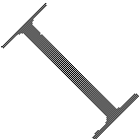

D igitalbase band

A nalog base band

RTC

BT

GS M

GP IO

US B

AD C

S IM

Audio

UA RT

P ow er

S upply

P ow er m anagem entunit

Radio Frequency

Analog Interface

D igitalInterface

**Figure 1: SIM800C functional diagram**

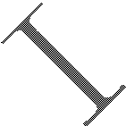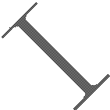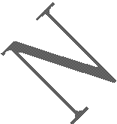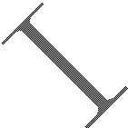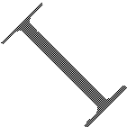

# Package Information

### Pin Out Diagram

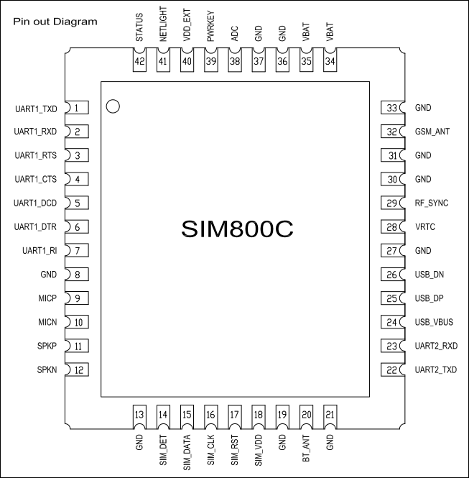

**Figure 2: Pin out Diagram (Top view)**

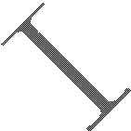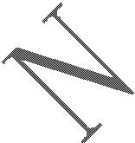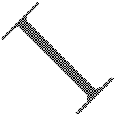

### Pin Description

**Table 5: Pin description**

|  |  |  |  |  |
| --- | --- | --- | --- | --- |
| **Pin name** | **Pin number** | **I/O** | **Description** | **Comment** |
| **Power supply** | | | | |
| VBAT | 34,35 | I | Power supply |  |

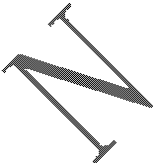

|  |  |  |  |  |
| --- | --- | --- | --- | --- |
| VRTC | 28 | I/O | Power supply for RTC | It is recommended to  connect with a battery or a capacitor (e.g. 4.7uF). |
| VDD_EXT | 40 | O | 2.8V power output | If these pins are unused,  keep open. |
| GND | 8,13,19,21,27,30,  31,33,36,37 |  | Ground | GND for VBAT recommend  to use 36,37pin |
| **Power on/down** | | | | |
| PWRKEY | 39 | I | PWRKEY should be pulled low at least 1 second and then released to  power on/down the module. | Internally pulled up to VBAT. |
| **Audio interfaces** | | | | |
| MICP | 9 | I | Differential audio input | If these pins are unused, keep open. |
| MICN | 10 |
| SPKP | 11 | O | Differential audio output |
| SPKN | 12 |
| **GPIO** | | | | |
| NETLIGHT | 41 | O | Network status |  |
| STATUS | 42 | O | Power on status |  |
| **Serial port** | | | | |
| UART1_DTR | 6 | I | Data terminal ready | If these pins are unused, keep open. |
| UART1_RI | 7 | O | Ring indicator |
| UART1_DCD | 5 | O | Data carrier detect |
| UART1_CTS | 4 | O | Clear to send |
| UART1_RTS | 3 | I | Request to send |
| UART1_TXD | 1 | O | Transmit data |
| UART1_RXD | 2 | I | Receive data |
| UART2_TXD | 22 | O | Transmit data |
| UART2_RXD | 23 | I | Receive data |
| **Debug interface** | | | | |
| USB_VBUS | 24 | I | Debug and download | If these pins are unused, keep open. |
| USB_DP | 25 | I/O |
| USB_DN | 26 | I/O |
| **ADC** | | | | |
| ADC | 38 | I | 10bit general analog to digital  converter | If these pins are unused,  keep open. |
| **SIM card interface** | | | | |
| SIM_VDD | 18 | O | Voltage supply for SIM card.  Support 1.8V or 3V SIM card | All signals of SIM interface should be protected against ESD with a TVS diode array. |
| SIM_DATA | 15 | I/O | SIM data input/output |
| SIM_CLK | 16 | O | SIM clock |
| SIM_RST | 17 | O | SIM reset |
| SIM_DET | 14 | I | SIM card detection | If these pins are unused, |

|  |  |  |  |  |
| --- | --- | --- | --- | --- |
|  |  |  |  | keep open. |
| **Antenna interface** | | | | |
| GSM_ANT | 32 | I/O | Connect GSM antenna |  |
| BT_ANT | 20 | I/O | Connect Bluetooth antenna |  |
| **Synchronizing signal of RF** | | | | |
| RF_SYNC | 29 | O | Synchronizing signal of RF |  |

### Package Dimensions



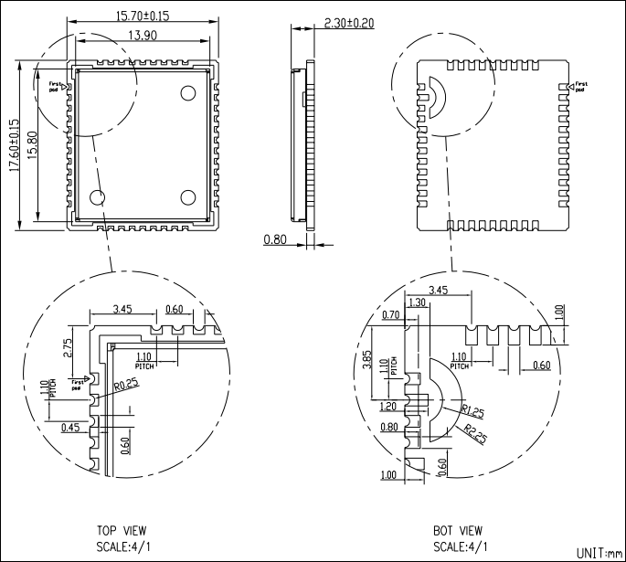

#### Figure 3: Dimensions of SIM800C (Unit: mm)

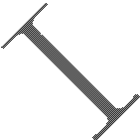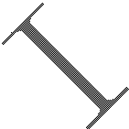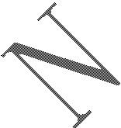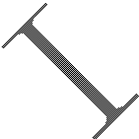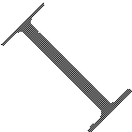

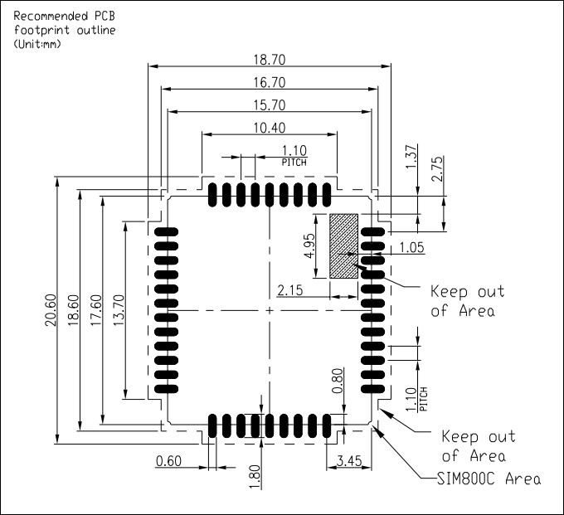

**Figure 4: Recommended PCB footprint outline (Unit: mm)**

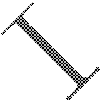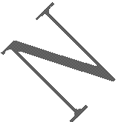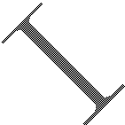

# Application Interface

### Power Supply

The power supply range of SIM800C is from 3.4V to 4.4V. Recommended voltage is 4.0V. The transmitting burst will cause voltage drop and the power supply must be able to provide sufficient current up to 2A. For the VBAT input, a bypass capacitor (low ESR) such as a 100 µF is strongly recommended.

For the VBAT input, a 100uF Tantalum capacitor (CA low ESR) and a 1uF~10uF Ceramics capacitor CB are strongly recommended. Increase the 33pF and 10pF capacitors can effectively eliminate the high frequency interference. A 5.1V/500mW Zener diode is strongly recommended, the diode can prevent chip from damaging by the voltage surge. These capacitors and Zener diode should be placed as close as possible to SIM800C VBAT pins.



V BAT



C A C B 33pF 10pF

5.1V

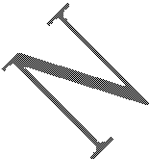

500m W

#### Figure 5: Reference circuit of the VBAT input

**Table 6: Recommended zener diode**

|  |  |  |  |  |
| --- | --- | --- | --- | --- |
|  | **Vendor** | **Part number** | **Power(watts)** | **Packages** |
| 1 | On semi | MMSZ5231BT1G | 500mW | SOD123 |
| 2 | Prisemi | PZ3D4V2H | 500mW | SOD323 |
| 3 | Vishay | MMSZ4689-V | 500mW | SOD123 |
| 4 | Crownpo | CDZ55C5V1SM | 500mW | 0805 |

The following figure is the reference design of +5V input power supply. The output power supply is 4.1V, thus a linear regulator can be used.



DC IN P U T

U 101 M IC 29302

VBAT



2

4

C 101+ 100uF

C 102

1

5

R 101 100K

+ C 103

330uF

C 104

1uF

P W R _CTRL

3

R 103 470Ω

100nF

R 102

43K

FB

O n/O ff

Vout

V in

GN D

#### Figure 6: Reference circuit of the LDO power supply

If there is a high drop-out between the input and the desired output (VBAT), a DC-DC power supply will be preferable because of its better efficiency especially with the 2A peak current in burst mode of the module. The

following figure is the reference circuit.

DC input

U 101

LM 2596-A D J

L101



1

V in

V out 2

C 101 + C 102

270Ω

5

O n/O ff

4

100uF

FB

3

100uH

D 102 C 103 +

330uF

M B R 360

C 104

1uF

R 101

2.2K

P W R _CT RL

100nF

R 102

1K

FB 101

VB AT

GN D

#### Figure 7: Reference circuit of the DC-DC power supply



The single 3.7V Li-ion cell battery can be connected to SIM800C VBAT pins directly. But the Ni-Cd or Ni-MH battery must be used carefully, since their maximum voltage can rise over the absolute maximum voltage of the module and damage it.

When battery is used, the total impedance between battery and VBAT pins should be less than 150mΩ.

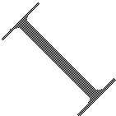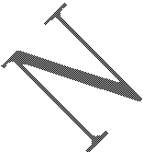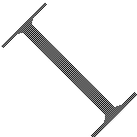

The following figure shows the VBAT voltage drop at the maximum power transmit phase, and the test condition is as following:

VBAT=4.0V,

A VBAT bypass capacitor CA=100µF tantalum capacitor (ESR=0.7Ω), Another VBAT bypass capacitor CB=1uF~10uF.

577us



4.615m s

B urst:2A

|  |  |  |  |  |  |  |  |  |
| --- | --- | --- | --- | --- | --- | --- | --- | --- |
| IVBAT |  | | | | | | | |
|  |  |  |  |  |  |  |  |

VB AT

M ax:350m V

#### Figure 8: VBAT voltage drop during transmit burst

#### Power Supply Pin

Pin34 and Pin35 are VBAT input, Pin36 and Pin37 are GND of power supply, and VRTC pin is power supply of the RTC circuit in the module. VDD_EXT output 2.8V when module is in normal operation mode.

When designing the power supply in customers’ application, pay special attention to power losses. Ensure that the input voltage never drops below 3.0V even when current consumption rises to 2A in the transmit burst. If the power voltage drops below 3.0V, the module may be shut down automatically. The PCB traces from the VBAT pins to the power supply must be wide enough (at least 60mil) to decrease voltage drops in the transmit burst. The power IC and the bypass capacitor should be placed to the module as close as possible.

VBAT

M IN :3.0V

#### Figure 9: The minimal VBAT voltage requirement at VBAT drop

***Note: Hardware power off voltage is 3.0V.***

#### Monitoring Power Supply

AT command “AT+CBC” can be used to monitor the VBAT voltage. For detail, please refer to ***document [1]***.

### Power on/off SIM800C

#### Power on SIM800C

Customer can power on SIM800C by pulling down the PWRKEY pin for at least 1 second and release. This pin is already pulled up to VBAT in the module internal, so external pull up is not necessary. Reference circuits are shown as below.

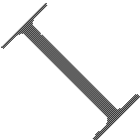

4.7K

Turn on/off im pulse

#### Figure 10: Powered on/down module using transistor



Pow er on/off logic

3V

100K

P W R KEY

1K

47K

M odule

|  |  |  |
| --- | --- | --- |
| PW R K EY | | 3V  100K  Pow er |
|  |  | 1K on/of logic  M odule |
|  | |

**Figure 11: Powered on/down module using button**

The power on timing is illustrated as in the following figure.

VB AT

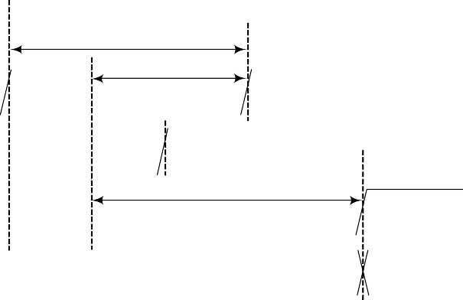

T> 1.5s

t> 1s

V IL<0.7V

T>55m s

t> 3s

U ndefind

A ctive

PW R K EY (INP UT )

VD D _EXT

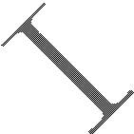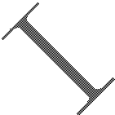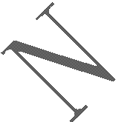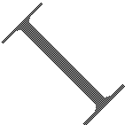

STA TU S

SerialP ort

#### Figure 12: Timing of power on module

When power on procedure is completed, SIM800C will send following URC to indicate that the module is ready to operate at fixed baud rate.

***RDY***

This URC does not appear when autobauding function is active.

***Note: Customer can use AT command “AT+IPR=x” to set a fixed baud rate and save the configuration to non-volatile flash memory. After the configuration is saved as fixed baud rate, the Code “RDY” should be received from the serial port every time when SIM800C is powered on. For details, please refer to the chapter “AT+IPR” in document [1].***

#### Power off SIM800C

SIM800C will be powered off in the following situations：



* Normal power off procedure: power off SIM800C by the PWRKEY pin.
* Normal power off procedure: power off SIM800C by AT command “AT+CPOWD=1”.
* Abnormal power off: over-voltage or under-voltage automatic power off.
* Abnormal power off: over-temperature or under-temperature automatic power off.

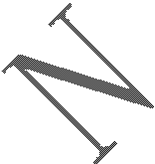

#### Power off SIM800C by the PWRKEY Pin

Customer can power off SIM800C by pulling down the PWRKEY pin for at least 1 second and release. Please refer to the power on circuit. The power off timing is illustrated in the following figure.

PW R K EY

(input)

VD D _EXT

1s<T 1<33s

V IL<0.7V



T 2≥2s

STATU S

T 3=2s

S erialport

A ctive

U ndifined

#### Figure 13: Timing of power off SIM800C by PWRKEY

***Note:***

1. ***the module will restart after pull down the pwrkey over 33 seconds.***
2. ***VDD_EXT will power off after STATUS change into low level and the PWRKEY release 55ms.. If 1s<T1<2s***，***T2>2s***；

***If 2s***≤***T1<33s***，***T2>T1+55ms***

This procedure makes the module log off from the network and allows the software to enter into a secure state to save data before completely shut down.

Before the completion of the power off procedure, the module will send URC:

***NORMAL POWER OFF***

At this moment, AT commands can not be executed any more. Power off mode can also be indicated by STATUS pin, which is at low level at this time.

#### Power off SIM800C by AT Command

SIM800C can be powered off by AT command “AT+CPOWD=1”. This procedure makes the module log off from the network and allows the software to enter into a secure state to save data before completely shut down.

Before the completion of the power off procedure, the module will send URC:

***NORMAL POWER OFF***

At this moment, AT commands can not be executed any more. Power off mode can also be indicated by STATUS pin, which is at low level at this time.

For detail about AT command “AT+CPOWD”, please refer to ***document [1]***.

#### Over-Voltage or Under-Voltage Power off



The module software monitors the VBAT voltage constantly. If the voltage ≤ 3.5V, the following URC will be reported:

***UNDER-VOLTAGE WARNNING***

If the voltage ≥ 4.3V, the following URC will be reported:

***OVER-VOLTAGE WARNNING***

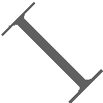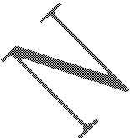

If the voltage < 3.4V, the following URC will be reported, and the module will be automatically powered off.

***UNDER-VOLTAGE POWER OFF***

If the voltage > 4.4V, the following URC will be reported, and the module will be automatically powered off.

***OVER-VOLTAGE POWER OFF***

At this moment, AT commands can not be executed any more. Power off mode can also be indicated by STATUS pin, which is at low level at this time.

#### Over-Temperature or Under-Temperature Power off

The module will constantly monitor the temperature of the module, If the temperature ≥ +80℃, the following URC will be reported:

***+CMTE: 1***

If the temperature ≤ -30℃, the following URC will be reported:

***+CMTE:-1***

If the temperature > +85℃, the following URC will be reported, and the module will be automatically powered off.

***+CMTE: 2***

If the temperature < -40℃, the following URC will be reported, and the module will be automatically powered off.

***+CMTE:-2***

At this moment, AT commands can not be executed any more. Power off mode can also be indicated by STATUS pin, which is at low level at this time.

***Note***：***The default temperature detect is disable, AT command “AT+CMTE” could be used to read the temperature when the module is running.For details please refer to document [1].***

#### Restart SIM800C by PWRKEY Pin:

When the module works normally, if the customer wants to restart the module, follow the procedure below:

1. Power off the module.
2. Wait for at least 800ms after STATUS pin changed to low level.
3. Power on the module.



1s<T 1<2s

T 3>800m s

T 2≥2s

PW R KEY

STA TU S

**Figure 14: Timing of restart SIM800C**

### Power Saving Mode

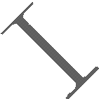

SIM800C has two power saving modes: Minimum functionality mode and sleep mode. AT command “AT+CSCLK=1”can be used to set SIM800C into sleep mode. AT command “AT+CFUN=<fun>“can be used to set SIM800C into minimum functionality. When SIM800C is in sleep mode and minimum functionality mode, the current of module is lowest.

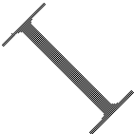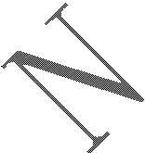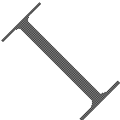

#### Minimum Functionality Mode

There are three functionality modes, which could be set by AT command “AT+CFUN=<fun>“. The command provides the choice of the functionality levels <fun>=0, 1, 4.

* AT+CFUN=0： Minimum functionality.
* AT+CFUN=1： Full functionality (default).
* AT+CFUN=4： Flight mode (disable RF function).

#### Table 7: The current consumption of Function Mode

|  |  |
| --- | --- |
| **<fun>** | **Current consumption(mA) (sleep mode)** |
| 0 | 0.6 |
| 1 | 0.88 |
| 4 | 0.65 |

Minimum functionality mode minimizes the current consumption to the lowest level. If SIM800C is set to minimum functionality by “AT+CFUN=0”, the RF function and SIM card function will be disabled. In this case, the serial port is still accessible, but partial AT commands and correlative to RF function and SIM card function will not be accessible.

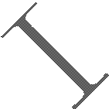

For detailed information about AT command “AT+CFUN=<fun>“, please refer to ***document [1]***.

#### Sleep Mode 1 (AT+CSCLK=1)

Customer can control SIM800C module to enter or exit the sleep mode (AT+CSCLK=1) by DTR signal. When DTR is in high level and without interrupt (on air and hardware such as GPIO interrupt or data in serial port), SIM800C will enter sleep mode automatically. In this mode, SIM800C can still receive paging or SMS from network but the serial port is not accessible.

#### Wake Up SIM800C from Sleep Mode 1

When SIM800C is in sleep mode 1(AT+CSCLK=1), the following methods can wake up the module:

* Pull down DTR pin.

The serial port will be active after DTR pin is pulled to low level for about 50ms.

* Receive a voice or data call from network.
* Receive a SMS from network.
* Receive external interrupt.

***Note: After module has received incoming call or new SMS, serial port can report URC, but the serial port can not input AT command. Only after the DTR pin is pulled to low level for 50ms, the serial port can input AT command.***

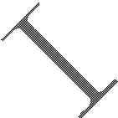

#### Sleep Mode 2 (AT+CSCLK=2)

In this mode, SIM800C will continuously monitor the serial port data signal. When there is no data transfer over 5 seconds on the RXD signal and there is no on air and hardware interrupts (such as GPIO interrupt), SIM800C will enter sleep mode 2 automatically. In this mode, SIM800C can still receive paging or SMS from network.



#### Wake Up SIM800C from Sleep Mode 2

When SIM800C is in sleep mode 2 (AT+CSCLK=2), the following methods can wake up the module:

* Send data to SIM800C via main serial port (the first character will lose).
* Receive a voice or data call from network.
* Receive a SMS from network.

***Note: Autobauding is default. It cannot enter sleep mode in the absence of synchronous serial port baud rate after module power on.***

### Power Saving Mode

Current input for RTC when the VBAT is not supplied for the system. Current output for backup battery when the VBAT power supply is in present and the backup battery is in low voltage state. The RTC power supply of module can be provided by an external capacitor or a battery (non-chargeable or rechargeable) through the VRTC. The following figures show various reference circuits for RTC back up.

#### External capacitor backup

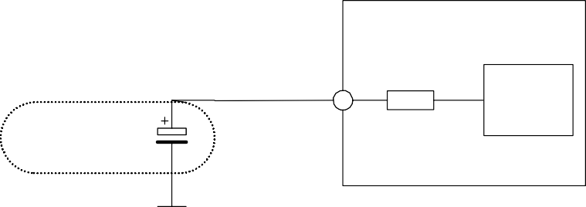

M odule

VR TC

1.5K

R TC

C ore

Large-capacitance

C apacitor

**Figure 15: RTC supply from capacitor**

#### Non-chargeable battery backup

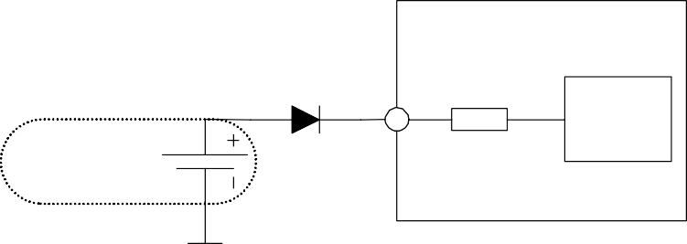

M odule

VR TC

1.5K

N on-chargeable

B ackup B attery

R T C

C ore

**Figure 16: RTC supply from non-chargeable battery**

#### Rechargeable battery backup

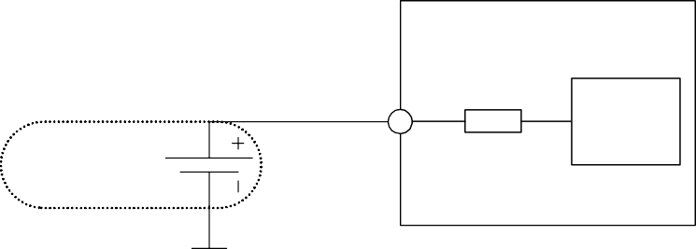

M odule

VR TC

1.5K

R echargeable

B ackup B attery

R T C

C ore

**Figure 17: RTC supply from rechargeable battery**

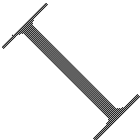

***Note: When shut off VBAT and power on VRTC only, the clock error becomes larger.***

### Serial Port and USB Interface

SIM800C default provides one unbalanced asynchronous serial ports. The module is designed as a DCE (Data Communication Equipment). The following figure shows the connection between module and client (DTE).

#### Table 8: Serial port and USB pin definition

|  |  |  |  |
| --- | --- | --- | --- |
|  | **Pin name** | **Pin number** | **Function** |
| Serial port | UART1_DTR | 6 | Data terminal ready |
| UART1_RI | 7 | Ring indicator |
| UART1_DCD | 5 | Data carrier detect |
| UART1_CTS | 4 | Clear to send |
| UART1_RTS | 3 | Request to send |
| UART1_TXD | 1 | Transmit data |
| UART1_RXD | 2 | Receive data |
| UART2_TXD | 22 | Transmit data |
| UART2_RXD | 23 | Receive data |
| Debug port | USB_VBUS | 24 | USB power supply |
| USB_DP | 25 | D+ data input/output |
| USB_DN | 26 | D- data input/output |

***Note: Hardware flow control is disabled by default. AT command “AT+IFC=2, 2”can enable hardware flow***

***control. AT command “AT+IFC=0,0”can disable hardware flow control. For more details please refer to document [1].***

#### Table 9: Serial port characteristics

**Symbol**

VIL VIH VOL

VOH

**Min**

-0.3

2.1

-

2.4

**Max**

0.7

3.1

0.4

-

**Unit**

V V V

V

#### Function of Serial Port

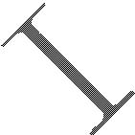

Serial port:

* Full mode device.
* Contain data lines UART1_TXD/UART1_RXD, hardware flow control lines UART1_RTS/UART1_CTS, status lines UART1_DTR、UART1_DCD and UART1_RI.

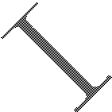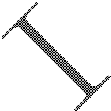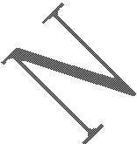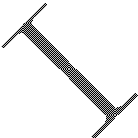

* Serial port can be used for GPRS service and AT communication. It can also be used for multiplexing function. For details about multiplexing function, please refer to *table 11*.
* Autobauding supports the following baud rates:

1200, 2400, 4800, 9600, 19200, 38400, 57600 and 115200bps

Autobauding allows SIM800C to automatically detect the baud rate of the host device. Pay more attention to the following requirements:

#### Synchronization between DTE and DCE:

When DCE powers on with autobauding enabled, it is recommended to send "AT" or "at" or "aT" or "At" to synchronize the baud rate, until DTE receives the "OK" response, which means DTE and DCE are correctly synchronized. For more information please refer to AT command "AT+IPR".

#### Restrictions of autobauding operation:

The DTE serial port must be set at 8 data bits, no parity and 1 stop bit.

The URC such as "RDY", "+CFUN: 1" and "+CPIN: READY” will not be reported.

***Note: Customer can use AT command “AT+IPR=x” to set a fixed baud rate and the setting will be saved to non-volatile flash memory automatically. After the configuration is set as fixed baud rate, the URC such as "RDY", "+CFUN: 1" and "+CPIN: READY” will be reported when SIM800C is powered on.***

#### Serial Interfaces

The following figure shows the connection between module and client (DTE).



|  |  |
| --- | --- |
| M odule(D C E ) SerialP ort | |
|  | UA R T1_TX D |
| UA R T1_RX D |
| UA R T1_RTS |
| UA R T1_CTS |
| UA R T1_DTR |
| UA R T1_DCD |
| UA R T1_RI |
| GN D |
|  | |

|  |  |
| --- | --- |
| C ustom er(D TE ) S erialP ort | |
| TX D |  |
| RX D |
| RTS |
| CTS |
| DTR |
| DCD |
| R IN G |
| G N D |
|  | |

#### Figure 18: Connection of the serial interfaces

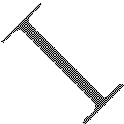

If the voltage of UART is 3.3V, the following reference circuits are recommended. If the voltage is 3.0V, please change the resistors in the following figure from 5.6K to 14K.

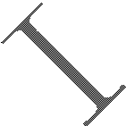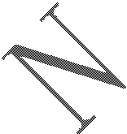

1K

RX D

1K

TX D

1K

RT S

1K

CT S

1K

GP IO

1K

GP IO

1K

E IN T

5.6K 5.6K 5.6K

GN D

D TE

(3.3V )

|  |  |
| --- | --- |
|  | |
|  | UA RT 1_TX D UA RT 1_RX D UA R T1_RTS UA R T1_CT S UA RT 1_DTR UA R T1_DCD  UA R T1_RI |
| GN D |
| M odule | |

#### Figure 19: Resistor matching circuit

If the voltage of UART is 3V or3.3V, the following reference circuits are recommended:



V D D _EXT

UA R T 1_RX D

UA RT 1_TX D

GN D

M odule D TE

10K

TX D

RX D

10K

GN D

#### Figure 20 : Diode isolation circuit

***Note: please make sure the minimum of client high limit should be less than 2.8V minus the diode drop.***

If the voltage of UART is 5V, the following reference circuits are recommended:

VD D _EXT



M odule

D TE

4.7K

VD D

VD D _EXT

4.7K

47K

UA RT 1_TX D

RX D

#### Figure 21: TX level matching circuit



VD D _EX T

4.7K

4.7K

47K

**Figure 22: RX level matching circuit**



M odule

D TE

VD D _EXT

VD D

UA RT 1_R X D

TX D

#### Debug Interface

SIM800C could achieve software debug function through USB interface. When powering on the module, connect USB_VBUS, USB_DP, USB_DN, and GND to PC, then install the driver following the prompts, a UART port could be recognized by PC, customer could achieve the software Debug with this UART port.

SIMCom recommended the following connected diagram:



U S B _VBU S

US B _ DN

US B _ D P

GN D

MO D U LE

VBU S

22 R

US B _ D N

22R

US B _D P

1uF

GN D

US B

#### Figure 23: USB reference circuit

The TVS on USB data line should be less than 5pF, and traced by differential forms.

***Note: please reserve the USB interface or test point for the further debugging***

#### Table 10: USB_VBUS operation voltage

|  |  |  |  |  |
| --- | --- | --- | --- | --- |
| **Pin** | **Min** | **Typ** | **Max** | **Unit** |
| USB_VBUS | 4.3 | 5.0 | 7.0 | V |

#### Software Upgrade

Customer could upgrade module’s firmware through USB or UART interface.

If upgrading through USB interface, it is necessary to power on SIM800C first, and then connect USB_VBUS, USB_DP, USB_DN, and GND to PC. There is no need to operate PWRKEY pin in the whole procedure, when SIM800C detects USB_VBUS and could communicate normally with USB_DP and USB_DN, it will enter USB download mode automatically.

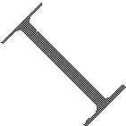

If customer upgrades the software through UART interface, it is strongly recommended to lead the UART1_TXD, UART1_RXD, GND and PWRKEY pin to IO connector for the upgrading, and PWRKEY pin should connect to GND while upgrading. Refer to the following figure for debugging and upgrading software.



M odule(D C E )

I/O C onnector

S erialP ort

UA R T 1_TX D TX D

UA R T 1_RX D

RX D

GN D

GN D

PW R K E Y

PW R K E Y

#### Figure 24: Connection for software upgrading and debugging

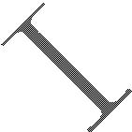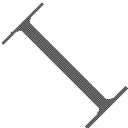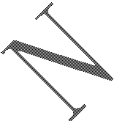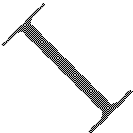

The UART interface supports the CMOS level. If customer connects the module to the computer, the level shifter should be added between the DCE and DTE.

### UART1_RI Behaviors

#### Table 11: RI behaviors

|  |  |
| --- | --- |
| **State** | **RI response** |
| Standby | High |
| Voice call | The pin is changed to low. When any of the following events occur, the pin will be changed to high:   1. Establish the call 2. Hang up the call |
| SMS | The pin is changed to low, and kept low for 120ms when a SMS is received. Then it is changed  to high. |
| Others | For more details, please refer to *document [2].* |

The behavior of the RI pin is shown in the following figure when the module is used as a receiver.

RI

H IG H

LO W

Idle

R ing

E stablish the cal H ang up the cal

#### Figure 25: UART1_RI behaviour of voice calling as a receiver

RI

H IG H

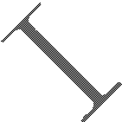

120m s

LO W

Idle

R eceive S M S UR C

#### Figure 26: UART1_RI behaviour of URC or receive SMS

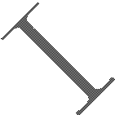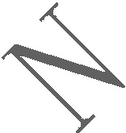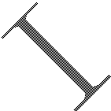

However, if the module is used as caller, the UART1_RI will remain high. Please refer to the following figure.

RI

H IG H

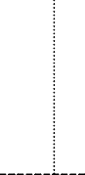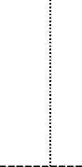

LO W

Idle R ing E stablish the cal

H ang up the cal

Idle

**Figure 27: UART1_RI behaviour as a caller**

### Audio Interfaces

SIM800C provides an analog input (MICP; MICN), which could be used for electret microphone. The module also provides an analog output (SPKP; SPKN).

#### Table 12: Audio interface definition

|  |  |  |
| --- | --- | --- |
| **Pin name** | **Pin number** | **Function** |
| MICP | 9 | Audio input positive |
| MICN | 10 | Audio input negative |
| SPKP | 11 | Audio output positive |
| SPKN | 12 | Audio output negative |

SPKP/SPKN output can directly drive 32Ω receiver.

AT command “AT+CMIC” is used to adjust the input gain level of microphone. AT command “AT+SIDET” is used to set the side-tone level. In addition, AT command “AT+CLVL” is used to adjust the output gain level. For more details, please refer to ***document [1]****.*

In order to improve audio performance, the following reference circuits are recommended. The audio signals have to be layout according to differential signal layout rules as shown in following figures.

#### Speaker Interfaces Configuration

33pF

**Figure 28: Speaker reference circuit**



C lose to speaker

10pF

33pF

10pF

33pF

ESD

SP KP

10pF

10pF

33pF

S PKN

M odule

10pF

33pF

10pF

33pF

ES D

#### Microphone Interfaces Configuration

These components should be placed to microphone as close as possible



M IC P

M IC N

M odule

The lines in bold type should be accorded to differential signal layout rules

10pF

10pF

10pF

33pF

33pF

33pF

ESD

ESD

Electret Microphone

#### Figure 29: Microphone reference circuit

* + 1. **Audio Electronic Characteristic Table 13: Microphone input characteristics**

|  |  |  |  |  |  |
| --- | --- | --- | --- | --- | --- |
| **Parameter** | | **Min** | **Typ** | **Max** | **Unit** |
| Microphone biasing voltage | | - | 1.9 | 2.2 | V |
| Working current | | - | - | 2.0 | mA |
| Input impedance(differential) | | 13 | 20 | 27 | KΩ |
| Idle channel noise | | - | - | -67 | dBm0 |
| SINAD | Input level:-40dBm0 | 29 | - | - | dB |

|  |  |  |  |  |  |  |  |
| --- | --- | --- | --- | --- | --- | --- | --- |
|  | Input level:0dBm0 | | | - | 69 | - | dB |
| **Table 14: Audio output characteristics** | | | | |  |  |  |
| **Parameter** | | **Conditions** | **Min** | | **Typ** | **Max** | **Unit** |
| Normal output | | RL=32 Ω receiver | - | | 15 | 90 | mW |

#### TDD

Audio signal could be interferenced by RF signal. Coupling noise could be filtered by adding 33pF and 10pF capacitor to audio lines. 33pF capacitor could eliminate noise from GSM850/EGSM900MHz, while 10pF capacitor could eliminate noise from DCS1800/PCS1900Mhz frequency. Customer should develop this filter solution according to field test result.



GSM antenna is the key coupling interfering source of TDD noise. Thereat, pay attention to the layout of audio lines which should be far away from RF cable, antenna and VBAT pin. The bypass capacitor for filtering should be placed near module and another group needs to be placed near to connector.

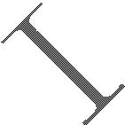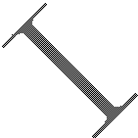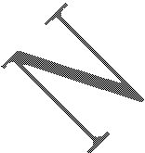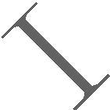

Conducting noise is mainly caused by the VBAT drop. If audio PA was powered by VBAT directly, then there will be some cheep noise from speaker output easily. So it is better to put big capacitors and ferrite beads near audio PA input.

TDD noise has something to do with GND signal. If GND plane is not good, lots of high-frequency noises will interference microphone and speaker over bypass capacitor. So a good GND during PCB layout could avoid TDD noise.

### SIM Card Interface

The SIM interface complies with the GSM Phase 1 specification and the new GSM Phase 2+ specification for FAST 64kbps SIM card. Both 1.8V and 3.0V SIM card are supported. The SIM interface is powered from an internal regulator in the module.

#### SIM Card Application Table 15: SIM pin definition

|  |  |  |
| --- | --- | --- |
| **Pin name** | **Pin number** | **Function** |
| SIM_VDD | 18 | Voltage supply for SIM card. Support 1.8V or 3V SIM card |
| SIM_DATA | 15 | SIM data input/output |
| SIM_CLK | 16 | SIM clock |
| SIM_RST | 17 | SIM reset |
| SIM_DET | 14 | SIM card detection |

It is recommended to use an ESD protection component such as ST ([www.st.com](http://www.st.com/) ) ESDA6V1-5W6 or ON SEMI ([www.onsemi.com](http://www.onsemi.com/) ) SMF05C. The SIM card peripheral components should be placed close to the SIM card holder. The reference circuit of the 8-pin SIM card holder is illustrated in the following figure.



M odule

VD D _EXT 4.7K

S IM _VD D S IM _R S T S IM _C LK S IM _D E T

S IM _D A TA

M O LE X -91228

51Ω

51Ω

VC C

RS T C LK

GN D

VPP

I/O

PR ESEN C E GN D

51Ω

S IM C ard

22pF

100nF

ESD A6V 1

#### Figure 30: Reference circuit of the 8-pin SIM card holder

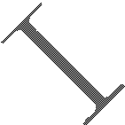

The SIM_DET pin is used for detection of the SIM card hot plug in. Customer can select the 8-pin SIM card holder to implement SIM card detection function. AT command “AT+CSDT” is used to enable or disable SIM card detection function. For details of this AT command, please refer to ***document [1]***.

If the SIM card detection function is not used, customer can keep the SIM_DET pin open. The reference circuit of 6-pin SIM card holder is illustrated in the following figure.

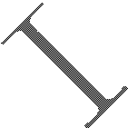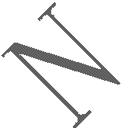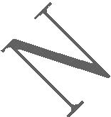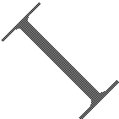

M odule

S IM _VD D

S IM _R S T

S IM _C LK S IM _D E T

S IM _D A TA

51Ω

51Ω

S IM C ard

VC C GN D

RS T VPP

C LK I/O

C 707 10M 006 512 2

51Ω

100nF

22pF

ESD A6V1

#### Figure 31: Reference circuit of the 6-pin SIM card holder

#### SIM Card Design Guide

SIM card signal could be interferenced by some high frequency signal, it is strongly recommended to follow these guidelines while designing:

* SIM card holder should be far away from GSM antenna
* SIM traces should keep away from RF lines, VBAT and high-speed signal lines
* The traces should be as short as possible
* Keep SIM card holder’s GND connect to main ground directly
* Shielding the SIM card signal by ground well
* Recommended to place a 100nF capacitor on SIM_VDD line and keep close to the SIM card holder
* Add some TVS which parasitic capacitance should not exceed 50pF
* Add 51Ω resistor to (SIM_RST/SIM_CLK/SIM_DATA) signal could enhance ESD protection

#### Design Considerations for SIM Card Holder

For 8 pins SIM card holder, SIMCom recommends to use Molex 91228.Customer can visit [http://www.molex.com](http://www.molex.com/) for more information about the holder.



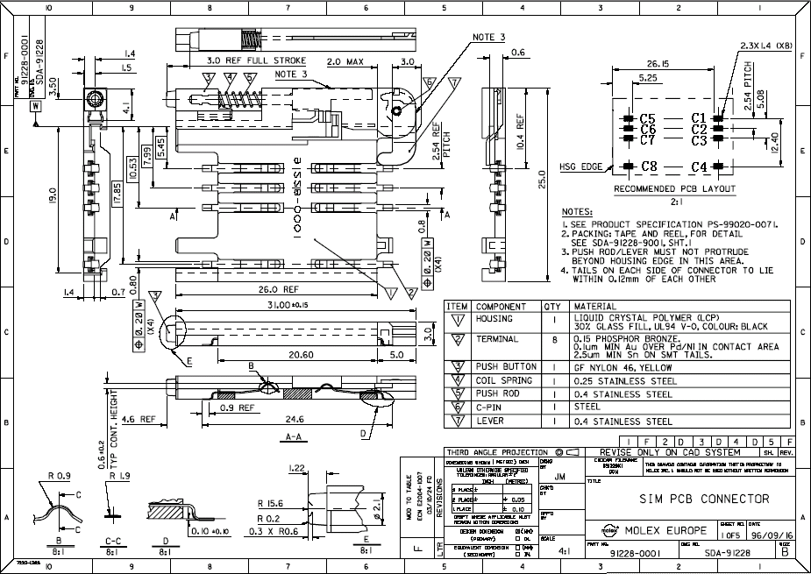

#### Figure 32: Molex 91228 SIM card holder

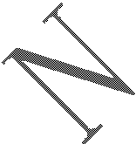

**Table 16: Pin description (Molex SIM card holder)**

|  |  |  |
| --- | --- | --- |
| **Pin name** | **Signal** | **Description** |
| C1 | SIM_VDD | SIM card power supply |
| C2 | SIM_RST | SIM card reset |
| C3 | SIM_CLK | SIM card clock |
| C4 | GND | Connect to GND |
| C5 | GND | Connect to GND |
| C6 | VPP | Not connect |
| C7 | SIM_DATA | SIM card data I/O |
| C8 | SIM_DET | Detect SIM card presence |

For 6-pin SIM card holder, SIMCom recommends to use Amphenol C707 10M006 512 .Customer can visit [http://www.amphenol.com](http://www.amphenol.com/) for more information about the holder.



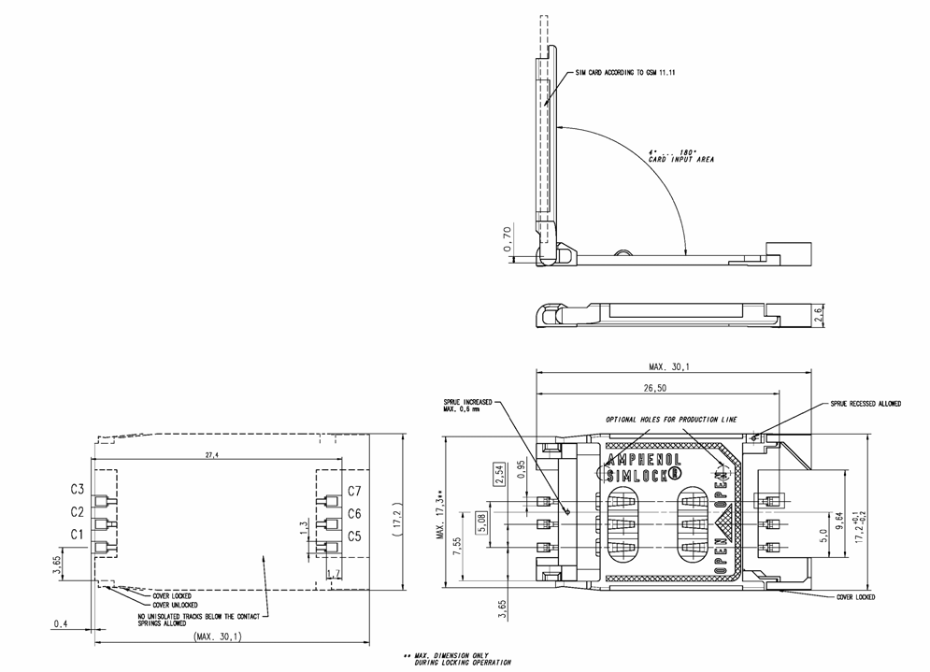

#### Figure 33: Amphenol C707 10M006 512 SIM card holder

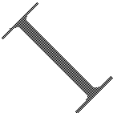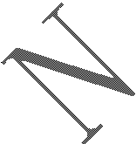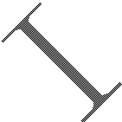

**Table 17: Pin description (Amphenol SIM card holder)**

|  |  |  |
| --- | --- | --- |
| **Pin name** | **Signal** | **Description** |
| C1 | SIM_VDD | SIM card power supply |
| C2 | SIM_RST | SIM card reset |
| C3 | SIM_CLK | SIM card clock |
| C5 | GND | Connect to GND |
| C6 | VPP | Not connect |
| C7 | SIM_DATA | SIM card data I/O |

***Note: Every time plug SIM card interval advice is greater than 2s. Otherwise may not be able to correct detection.***



### ADC

#### Table 18: Pin definition of the ADC

|  |  |  |
| --- | --- | --- |
| **Pin name** | **Pin number** | **Description** |
| ADC | 38 | Analog voltage input |

SIM800C provides an auxiliary ADC, which can be used to measure the voltage. Customer can use AT command “AT+CADC” to read the voltage value. For details of this AT command, please refer to ***document [1]***.

**Table 19: ADC specification**

|  |  |  |  |  |
| --- | --- | --- | --- | --- |
| **Parameter** | **Min** | **Typ** | **Max** | **Unit** |
| Voltage range | 0 | - | 2.8 | V |
| ADC Resolution | - | 10 | - | bits |
| Sampling rate | - | - | 1.0833 | MHz |
| ADC precision |  | 10 | 30 | mV |

### Network Status Indication

#### Table 20: Pin definition of the NETLIGHT

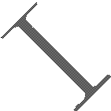

|  |  |  |
| --- | --- | --- |
| **Pin name** | **Pin number** | **Description** |
| NETLIGHT | 41 | Network Status Indication |

The NETLIGHT pin can be used to drive a network status indication LED. The status of this pin is listed in following table:

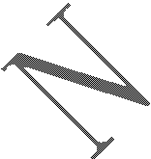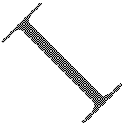

#### Table 21: Status of the NETLIGHT pin

|  |  |
| --- | --- |
| **Status** | **SIM800C behavior** |
| Off | Powered off |
| 64ms On/ 800ms Off | Not registered the network |
| 64ms On/ 3000ms Off | Registered to the network |
| 64ms On/ 300ms Off | GPRS communication is established |

Reference circuit is recommended in the following figure:

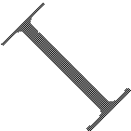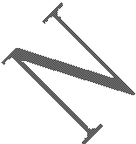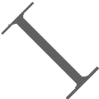

VBAT



M odule

NE TLIG HT

R

4.7K

47K

#### Figure 34: Reference circuit of NETLIGHT

* + 1. **NETLIGHT Multiplexing Function Table 22: NETLIGHT multiplexing function**

|  |  |  |  |
| --- | --- | --- | --- |
| **Pin name** | **Pin number** | **Mode 0(default)** | **Mode 1** |
| NETLIGHT | 41 | NETLIGHT | GPIO |

***Note: Multiplexing function need different software supply.***

### Operating Status Indication

The pin42 is for operating status indication of the module. The pin output is high when module is powered on, and output is low when module is powered off.

#### Table 23: Pin definition of the STATUS

|  |  |  |
| --- | --- | --- |
| **Pin name** | **Pin number** | **Description** |
| STATUS | 42 | Operating status indication |

***Note: For timing about STATUS, please reference to the chapter “4.2 power on/down scenarios”***



#### STATUS Multiplexing Function Table 24: STATUS multiplexing function

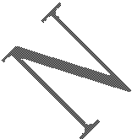

|  |  |  |  |
| --- | --- | --- | --- |
| **Pin name** | **Pin number** | **Mode 0(default)** | **Mode 1** |
| STATUS | 42 | STATUS | GPIO |

***Note: Multiplexing function need different software supply.***

### RF Synchronization Signal

The synchronization signal is used to indicate incoming GSM burst.

#### Table 25: Definition of the RF_SYNC pin

|  |  |  |
| --- | --- | --- |
| **Pin name** | **Pin number** | **Description** |
| RF_SYNC | 29 | Transmit synchronization signal |

The timing of the synchronization signal is shown below.



220us

T ransm itburst

R F_SYN C

577us

#### Figure 35: RF_SYNC signal during transmit burst

#### RF_SYNC Multiplexing Function

RF_SYNC can also be used as GPIO to indicate the RF Jamming. The RF_SYNC function and RF Jamming Detection function can be switched by AT+SJDR command.

#### Table 26: RF_SYNC Multiplexing function

|  |  |  |  |
| --- | --- | --- | --- |
| **Pin name** | **Pin number** | **Mode 0(default)** | **Mode 1** |
| RF_SYNC | 29 | RF Synchronization Signal | JD（RF jamming detection） |

***Note: About AT+SJDR, please refer to document [1].***

### Antenna Interface

There are two antenna interfaces, GSM_ANT and BT_ANT.

* The input impendence of the antenna should be 50Ω, and the VSWR should be less than 2.
* It is recommended that the GSM antenna and the BT antenna should be placed as far as possible.
* The isolations of the two antenna should be bigger than 30dB

***NOTE***：***About the RF trace layout please refer to“AN_SMT Module_RF_Reference Design_Guide”.***



#### GSM Antenna Interface

SIM800C provides a GSM antenna named GSM_ANT, customer could use 50Ω microstrip line or stripline antenna connect to the module.

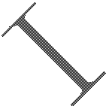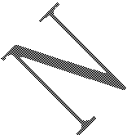

It is recommended to reserve the matching circuit as following:

GS M



GN D (P in31)

M odule R F connector

GS M _A N T R 101

(P in33)

C 101 C102

GN D (P in33)

Antenna

#### Figure 36: GSM antenna matching circuit

R101，C101，C102 are the matching circuit, the value should be defined by the antenna design. Normally R101 is 0Ω, C101 and C102 are not mounted.

The RF connector is used for conduction test. If the space between RF pin and antenna is not enough, the matching circuit should be designed as in the following figure:

GN D (P in31)



M odule

GS M _A N T

(P in33)

R 101

C 101 C102

GS M

Antenna

GN D (P in33)

#### Figure 37: GSM antenna matching circuit without RF connector

Normally R101 is 0Ω, C101 and C102 are not mounted.

#### Bluetooth Antenna Interface

It is recommended to reserve the matching circuit as following:

GN D (P in19)



## M odule

BT_A N T (P in20)

R 201

C201 C 202

BT

Antenna

GN D (P in21)

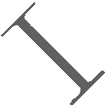

#### Figure 38: Bluetooth antenna matching circuit

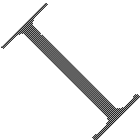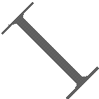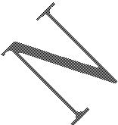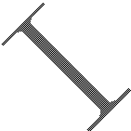

R201, C201, C202 are the matching circuit, the value should be defined by the antenna design. Normally R201 is 0R, C202 and C201 are not mounted.

There are some suggestions for placing components and RF trace for GSM_ANT/BT_ANT:

* The RF connector is used for conducted test, so keep it as close to pin GSM_ANT as possible;
* Antenna matching circuit should be close to the antenna;
* Keep the RF traces impedance as 50Ω;
* The RF traces should be kept far away from the high frequency signals and strong interference source.

# PCB Layout

This section will give some guidelines on PCB layout, in order to eliminate interfere or noise.

### Pin Assignment

Before PCB layout, we should learn about pin assignment in order to get reasonable layout with so many external components. Following figure is the overview of pin assignment of the module.

**VBAT**

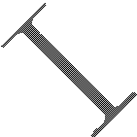

STATUS NETLIGHT VDD_EXT PWRKEY ADC

GND

GND

VBAT

VBAT

42

41

40

39

38

37

36

35

34

1

33

2

32

3

31

4

30

5

29

**SIM800C**

6

28

**TOP VIEW**

7

27

8

26

MICP 9

25

MICN 10

24

SPKP 11

23

SPKN 12

22

13

14

15

16

17

18

19

20

21

GND

SIM_DET SIM_DATA SIM_CLK SIM_RST SIM_VDD GND

BT_ANT

GND

UART2_TXD

UART2_RXD

USB_VBUS

USB_DP

USB_DM

GND

VRTC

RF_SYNC

GND

GND

GSM_ANT

GND

GND

UART1_RI

UART1_DTR

UART1_DCD

UART1_CTS

UART1_RTS

UART1_RXD

UART1_TXD

**UART**



**AUDIO**

**SIM CART**

UART1_DTR

**USB**

**ANTANA**

**GND**

**OTHERS**

**Figure 39: Pin assignment**

### Principle of PCB Layout

During layout, attention should be paid to the following interfaces, like Antenna, power supply, SIM card interface, audio interface, and so on.

#### Antenna Interface

* + - * The length of trace between pin output and connector should be as short as possible;
      * Do not trace RF signal over across the board;
      * The RF signal should be far away from SIM card, power ICs.

#### Power Supply

* + - * Not only VBAT but also return GND are very important in layout;
      * The positive line of VBAT should be as short and wide as possible;
      * The correct flow from source to VBAT pin should go though Zener diode then huge capacitor;



* + - * Pin 36 and Pin37 are GND signals, and shortest layout to GND of power source should be designed;
      * There are 10 GND pads in the module; these pads could enhance the GND performances. On the upper layer of these pads, do not trace any signal if possible.

#### SIM Card Interface

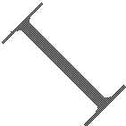

* + - * SIM card holder has no anti-EMI component inside. Thus SIM card interface maybe interfered, please pay more attention on this interface during layout;
      * Ensure SIM card holder is far way from antenna or RF cable inside;
      * Put SIM card holder near the module, as nearer as possible;
      * Add ESD component to protect SIM_CLK, SIM_DATA, SIM_RST and SIM_VDD signals which should be far away from power and high-speed-frequency signal.

#### Audio Interface

* + - * The signal trace of audio should far away from antenna and power;
      * The audio signal should avoid to parallel with VBAT trace.

#### Others

* + - * It is better to trace signal lines of UART bunched, as well as signals of USB.

# Electrical, Reliability and Radio Characteristics

### Absolute Maximum Ratings

The absolute maximum ratings stated in following table are stress ratings under non-operating conditions. Stresses beyond any of these limits will cause permanent damage to SIM800C.

#### Table 27: Absolute maximum ratings



|  |  |  |  |  |
| --- | --- | --- | --- | --- |
| **Symbol** | **Min** | **Typ** | **Max** | **Unit** |
| VBAT | - | - | 4.5 | V |
| Current | 0 | - | 2.0 | A |
| USB_VBUS | - | - | 12 | V |
| II* | - | 4 | 16 | mA |
| IO* | - | 4 | 16 | mA |

*These parameters are for digital interface pins, GPIO, and UART.

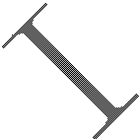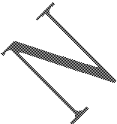

### Recommended Operating Conditions

**Table 28: Recommended operating conditions**

|  |  |  |  |  |  |
| --- | --- | --- | --- | --- | --- |
| **Symbol** | **Parameter** | **Min** | **Typ** | **Max** | **Unit** |
| VBAT | Power supply voltage | 3.4 | 4.0 | 4.4 | V |
| TOPER | Operating temperature | -40 | +25 | +85 | ℃ |
| TSTG | Storage temperature | -45 |  | +90 | ℃ |

### Digital Interface Characteristics

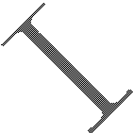

**Table 29: Digital interface characteristics**

|  |  |  |  |  |  |
| --- | --- | --- | --- | --- | --- |
| **Symbol** | **Parameter** | **Min** | **Typ** | **Max** | **Unit** |
| VIH | High-level input current | 2.1 | - | 3.1 | V |
| VIL | Low-level input current | -0.3 | - | 0.7 | V |
| VOH | High-level output voltage | 2.4 | - | - | V |
| VOL | Low-level output voltage | - | - | 0.4 | V |
| ***Note: These parameters are for digital interface pins, such as keypad, GPIO and UART.***  **6.4 SIM Card Interface Characteristics**  **Table 30: SIM card interface characteristics** | | | | |  |
| **Symbol** | **Parameter** | **Min** | **Typ** | **Max** | **Unit** |
| IIH | High-level input current | -1.0 | - | 1.0 | uA |
| IIL | Low-level input current | -1.0 | - | 1.0 | uA |

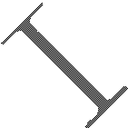

|  |  |  |  |  |  |
| --- | --- | --- | --- | --- | --- |
| VIH | High-level input voltage | 1.4 | - | - | V |
| 2.4 | - | - | V |
| VIL | Low-level input voltage | - | - | 0.27 | V |
|  |  | 0.4 | V |
| VOH | High-level output voltage | 1.62 | - | - | V |
| 2.7 | - | - | V |
| VOL | Low-level output voltage | - | - | 0.36 | V |
| - | - | 0.4 | V |
| **6.5 SIM_VDD Characteristics**  **Table 31: SIM_VDD characteristics** | |  |  |  | |
| **Symbol** | **Parameter** | **Min** | **Typ** | **Max** | **Unit** |
| VO | Output voltage | - | 3.0 | - | V |
| - | 1.8 | - |
| IO | Output current | - | - | 10 | mA |
| **6.6 VDD_EXT Characteristics**  **Table 32: VDD_EXT characteristics** | | | | |  |
| **Symbol** | **Parameter** | **Min** | **Typ** | **Max** | **Unit** |
| VO | Output voltage | 2.7 | 2.8 | 2.9 | V |
| IO | Output current | - | - | 50 | mA |
| **6.7 VRTC Characteristics**  **Table 33: VRTC characteristics** | | |  |  |  |
| **Symbol** | **Description** | **Min** | **Typ** | **Max** | **Unit** |
| VRTC-IN | VRTC input voltage | 1.2 | 2.8 | 3.0 | V |
| IRTC-IN | VRTC input current | - | 3.0 | 5.0 | uA |
| VRTC-OUT | VRTC output voltage | - | 2.8 | - | V |
| IRTC-OUT | VRTC output current | - |  | 2.0 | mA |

### Current Consumption (VBAT=4.0V)

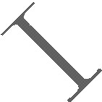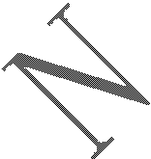

#### Table 34: Current consumption

|  |  |  |  |  |  |  |
| --- | --- | --- | --- | --- | --- | --- |
| **Symbol** | **Parameter** | **Conditions** | **Min** | **Typ** | **Max** | **Unit** |
| VBAT | Voltage |  |  | 4.0 |  | V |
| Power drop | PCL=5 |  |  | 350 | mV |
| Voltage ripple | PCL=5  @ f<200kHz |  |  | 50 | mV |



|  |  |  |  |  |  |  |
| --- | --- | --- | --- | --- | --- | --- |
|  |  | @ f>200kHzss |  |  | 2.0 | mV |
| IVBAT | Average currnet | Power off mode |  | 130 | 150 | uA |
| Sleep mode (AT+CFUN=1)： ( BS-PA-MFRMS=9 )  ( BS-PA-MFRMS=5)  ( BS-PA-MFRMS=2) |  | 0.88  1  1.5 |  | mA mA mA |
| Idle mode (AT+CFUN=1)： GSM850  EGSM900  DCS1800 PCS1900 |  | 13.8  13.8  13.8  13.8 |  | mA mA mA mA |
| Voice call (PCL=5)： GSM850 EGSM900  Voice call (PCL=0)：  DCS1800 PCS1900 |  | 209  211  126  413 |  | mA mA  mA mA |
| Data mode GPRS (1Rx,4Tx)： GSM850  EGSM900 DCS1800  PCS1900 |  | 394  416  271  285 |  | mA mA mA mA |
| Data mode GPRS (3Rx,2Tx)： GSM850  EGSM900  DCS1800 PCS1900 |  | 323  330  212  227 |  | mA mA mA mA |
| Data mode GPRS (4Rx,1Tx)： GSM850  EGSM900 DCS1800  PCS1900 |  | 213  210  150  162 |  | mA mA mA mA |
| IMAX | Peak current | During Tx burst |  |  | 2.0 | A |

***Note: In above table the current consumption value is the typical one of the module tested in laboratory. In the mass production stage, there may be differences among each individual.***



### Electro-Static Discharge

SIM800C is an ESD sensitive component, so attention should be paid to the procedure of handling and packaging. The ESD test results are shown in the following table.

**Table 35: The ESD characteristics (Temperature: 25**℃**, Humidity: 45 %)**

|  |  |  |
| --- | --- | --- |
| **Pin name** | **Contact discharge** | **Air discharge** |
| VBAT | ±5KV | ±12KV |

|  |  |  |
| --- | --- | --- |
| GND | ±6KV | ±12KV |
| UART1_TXD /UART1_RXD | ±4KV | ±8KV |
| Antenna port | ±5KV | ±10KV |
| SPKP/SPKN/MICP/MICN | ±4KV | ±8KV |
| PWRKEY | ±4KV | ±8KV |

### Radio Characteristics

#### Module RF Output Power

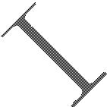

The following table shows the module conducted output power, it is followed by the 3GPP TS 05.05 technical specification requirement.

#### Table 36: GSM850 and EGSM900 conducted RF output power

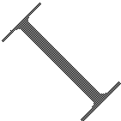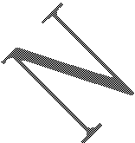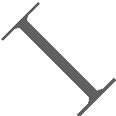

|  |  |  |  |
| --- | --- | --- | --- |
| **GSM850,EGSM900** | | | |
| **PCL** | **Nominal output power (dBm)** | **Tolerance (dB) for conditions** | |
| **Normal** | **Extreme** |
| 5 | 33 | ±2 | ±2.5 |
| 6 | 31 | ±3 | ±4 |
| 7 | 29 | ±3 | ±4 |
| 8 | 27 | ±3 | ±4 |
| 9 | 25 | ±3 | ±4 |
| 10 | 23 | ±3 | ±4 |
| 11 | 21 | ±3 | ±4 |
| 12 | 19 | ±3 | ±4 |
| 13 | 17 | ±3 | ±4 |
| 14 | 15 | ±3 | ±4 |
| 15 | 13 | ±3 | ±4 |
| 16 | 11 | ±5 | ±6 |
| 17 | 9 | ±5 | ±6 |
| 18 | 7 | ±5 | ±6 |
| 19-31 | 5 | ±5 | ±6 |

**Table 37: DCS1800 and PCS1900 conducted RF output power**

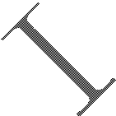

|  |  |  |  |
| --- | --- | --- | --- |
| **DCS1800,PCS1900** | | | |
| **PCL** | **Nominal output power (dBm)** | **Tolerance (dB) for conditions** | |
| **Normal** | **Extreme** |
| 0 | 30 | ±2 | ±2.5 |
| 1 | 28 | ±3 | ±4 |
| 2 | 26 | ±3 | ±4 |
| 3 | 24 | ±3 | ±4 |

|  |  |  |  |
| --- | --- | --- | --- |
| 4 | 22 | ±3 | ±4 |
| 5 | 20 | ±3 | ±4 |
| 6 | 18 | ±3 | ±4 |
| 7 | 16 | ±3 | ±4 |
| 8 | 14 | ±3 | ±4 |
| 9 | 12 | ±4 | ±5 |
| 10 | 10 | ±4 | ±5 |
| 11 | 8 | ±4 | ±5 |
| 12 | 6 | ±4 | ±5 |
| 13 | 4 | ±4 | ±5 |
| 14 | 2 | ±5 | ±6 |
| 15 | 0 | ±5 | ±6 |

#### Module RF Receive Sensitivity

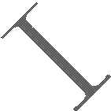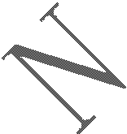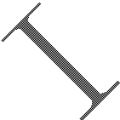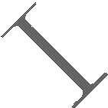

The following table shows the module’s conducted receiving sensitivity, it is tested under static condition.

#### Table 38: Conducted RF receive sensitivity

|  |  |  |
| --- | --- | --- |
| **Frequency** | **Receive sensitivity**（**Typical**） | **Receive sensitivity(Max)** |
| GSM850,EGSM900 | < -109dBm | < -107dBm |
| DCS1800,PCS1900 | < -109dBm | < -107dBm |

#### Module Operating Frequencies

The following table shows the module’s operating frequency range; it is followed by the 3GPP TS 05.05 technical specification requirement.

**Table 39: Operating frequencies**

|  |  |  |
| --- | --- | --- |
| **Frequency** | **Receive** | **Transmit** |
| GSM850 | 869 ～ 894MHz | 824 ～ 849MHz |
| EGSM900 | 925 ～ 960MHz | 880 ～ 915MHz |
| DCS1800 | 1805 ～ 1880MHz | 1710 ～ 1785MHz |
| PCS1900 | 1930 ～ 1990MHz | 1850 ～ 1910MHz |

# Manufacturing

### Top and Bottom View of SIM800C

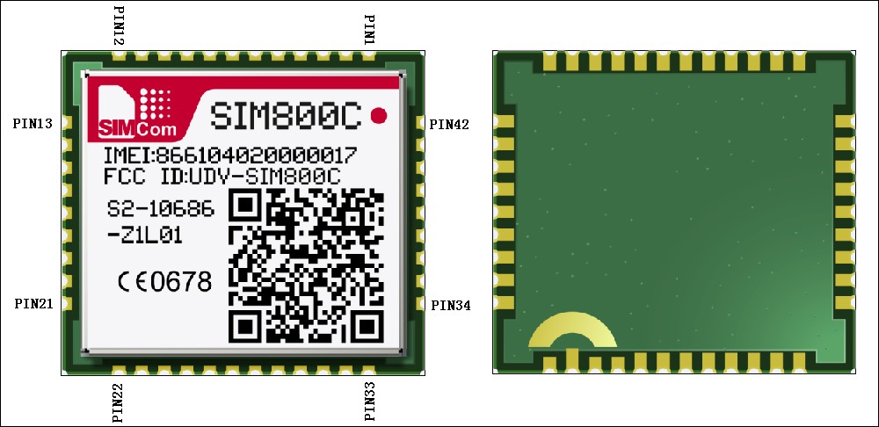

**Figure 40: Top and bottom view of SIM800C**

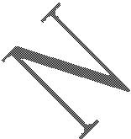

### Typical Solder Reflow Profile

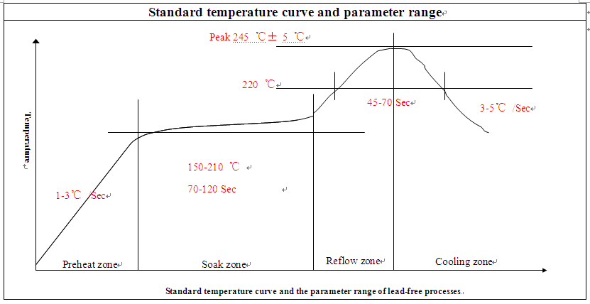

**Figure 41: Typical solder reflow profile of lead-free processes**

### The Moisture Sensitivity Level

The moisture sensitivity level of SIM800C module is 3. The modules should be mounted within 168 hours after unpacking in the environmental conditions of temperature <30℃ and relative humidity of <60% (RH). It is necessary to bake the module if the above conditions are not met:

#### Table 40: Moisture sensitivity level and floor life



|  |  |
| --- | --- |
| **Moisture Sensitivity Level**  **(MSL)** | **Floor Life (out of bag) at factory ambient**≤**30**°**C/60% RH or as stated** |
| 1 | Unlimited at ≦30℃/85% RH |
| 2 | 1 year |
| 2a | 4 weeks |
| 3 | 168 hours |
| 4 | 72 hours |
| 5 | 48 hours |
| 5a | 24 hours |
| 6 | Mandatory bake before use. After bake, it must be reflowed within the time limit  specified on the label. |

***NOTES:***

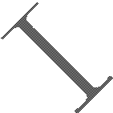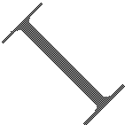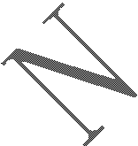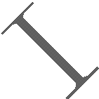

***For product handling, storage, processing, IPC / JEDEC J-STD-033 must be followed.***

### Baking Requirements

SIM800C modules are vacuum packaged, and guaranteed for 6 months storage without opening or leakage under the following conditions: the environment temperature is lower than 40℃, and the air humidity is less than 90%.

If the condition meets one of the following ones shown below, the modules should be baked sufficiently before re-flow soldering, and the baking condition is shown in below table; otherwise the module will be at the risk of permanent damage during re-flow soldering.

* If the vacuum package is broken or leakage;
* If the vacuum package is opened after 6 months since it’s been packed;
* If the vacuum package is opened within 6 months but out of its Floor Life at factory ambient≦30℃

/60%RH or as stated.

#### Table 41: Baking requirements

|  |  |  |
| --- | --- | --- |
| **Baking temperature** | **Moisture** | **Time** |
| 40℃±5℃ | <5% | 192 hours |
| 120℃±5℃ | <5% | 6 hours |

***Note: Care should be taken if that plastic tray is not heat-resistant, the modules should be taken out for preheating, otherwise the tray may be damaged by high-temperature heating.***

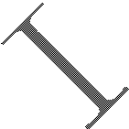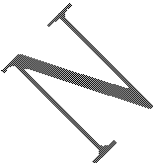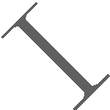

# Appendix

### Related Documents

**Table 42: Related documents**



|  |  |  |
| --- | --- | --- |
| **SN** | **Document name** | **Remark** |
| [1]  [2]  [3]  [4] | SIM800 Series AT Command  Manual |  |
| SIM800 Series UART Port  Application Note_V1 02.doc |  |
| ITU-T Draft new  recommendation V.25ter： | Serial asynchronous automatic dialing and control |
| GSM 07.07： | Digital cellular telecommunications (Phase 2+); AT command set for  GSM Mobile Equipment (ME) |
| [5] | GSM 07.10： | Support GSM 07.10 multiplexing protocol |
| [6] | GSM 07.05： | Digital cellular telecommunications (Phase 2+); Use of Data Terminal Equipment – Data Circuit terminating Equipment (DTE – DCE) interface for Short Message Service (SMS) and Cell  Broadcast Service (CBS) |
| [7] | GSM 11.14： | Digital cellular telecommunications system (Phase 2+); Specification of the SIM Application Toolkit for the Subscriber  Identity Module – Mobile Equipment (SIM – ME) interface |
| [8] | GSM 11.11： | Digital cellular telecommunications system (Phase 2+); Specification of the Subscriber Identity Module – Mobile  Equipment (SIM – ME) interface |
| [9] | GSM 03.38： | Digital cellular telecommunications system (Phase 2+); Alphabets  and language-specific information |
| [10] | GSM 11.10 | Digital cellular telecommunications system (Phase 2)； Mobile Station (MS) conformance specification； Part 1： Conformance  specification |
| [11] | AN_Serial Port | AN_Serial Port |

### Multiplexing Function

#### Table 43: Multiplexing function



|  |  |  |  |  |  |  |
| --- | --- | --- | --- | --- | --- | --- |
| **Pin name** | **Reset** | **Pin number** | **Mode 0(default)** | **Mode 1** | **Mode 2** | **Mode 3** |
| STATUS | I/PD | 42 | STATUS | GPIO19 | - |  |
| SIM_DET | I/PD | 14 | SIM_DET | GPIO20 | EINT14 |  |
| NETLIGHT | I/PD | 41 | NETLIGHT | GPIO17 | UTXD3 |  |
| UART1_DTR | I/PD | 6 | UART1_DTR | GPIO18 | EINT13 |  |
| UART1_RI | I/PD | 7 | UART1_RI | GPIO13 | EINT11 |  |
| UART1_DCD | I/PD | 5 | UART1_DCD | GPIO12 | URXD3 |  |
| UART1_CTS | I/PD | 4 | UART1_CTS | GPIO14 | EINT12 |  |
| UART1_RTS | I/PD | 3 | UART1_RTS | GPIO15 |  |  |
| UART1_TXD | HO | 1 | UART1_TXD | GPIO11 |  |  |
| UART1_RXD | I/PD | 2 | UART1_RXD | GPIO10 |  |  |
| UART2_TXD | HO | 22 | UART3_TXD | GPIO0 |  |  |
| UART2_RXD | I/PD | 23 | UART3_RXD | GPIO1 |  |  |

***Note: Multiplexing function need different software supply.***



### Terms and Abbreviations

**Table 44: Terms and abbreviations**

**Abbreviation**

ADC AMR CS CTS DTE DTR DTX EFR EGSM ESD ETS FR GPRS GSM HR MO MS MT

PAP

**Description**

Analog-to-Digital Converter Adaptive Multi-Rate Coding Scheme

Clear to Send

Data Terminal Equipment (typically computer, terminal, printer) Data Terminal Ready

Discontinuous Transmission Enhanced Full Rate Enhanced GSM Electrostatic Discharge

European Telecommunication Standard Full Rate

General Packet Radio Service

Global Standard for Mobile Communications Half Rate

Mobile Originated

Mobile Station (GSM engine), also referred to as TE Mobile Terminated

Password Authentication Protocol

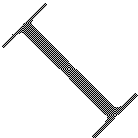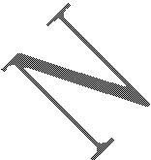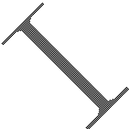

|  |  |
| --- | --- |
| PBCCH | Packet Broadcast Control Channel |
| PCB | Printed Circuit Board |
| PCL | Power Control Level |
| PCS | Personal Communication System, also referred to as GSM 1900 |
| PDU | Protocol Data Unit |
| PPP | Point-to-point protocol |
| RF | Radio Frequency |
| RMS | Root Mean Square (value) |
| RX | Receive Direction |
| SIM | Subscriber Identification Module |
| SMS | Short Message Service |
| TE | Terminal Equipment, also referred to as DTE |
| TX | Transmit Direction |
| SINAD | Signal to Noise and Distortion Ratio |
| UART | Universal Asynchronous Receiver & Transmitter |
| URC | Unsolicited Result Code |
| USSD | Unstructured Supplementary Service Data |
| **Phonebook abbreviations** | |
| FD | SIM fix dialing phonebook |
| LD | SIM last dialing phonebook (list of numbers most recently dialed) |
| MC | Mobile Equipment list of unanswered MT calls (missed calls) |
| ON | SIM (or ME) own numbers (MSISDNs) list |
| RC | Mobile Equipment list of received calls |
| SM | SIM phonebook |
| NC | Not connect |

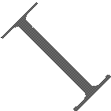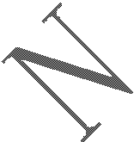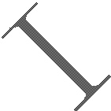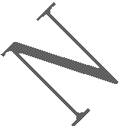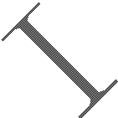

### Safety Caution

**Table 45: Safety caution**

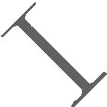

|  |  |
| --- | --- |
| **Marks** | **Requirements** |
|  | When in a hospital or other health care facility, observe the restrictions about the use of mobiles. Switch the cellular terminal or mobile off, medical equipment may be sensitive to not operate  normally for RF energy interference. |
|  | Switch off the cellular terminal or mobile before boarding an aircraft. Make sure it is switched off. The operation of wireless appliances in an aircraft is forbidden to prevent interference with communication systems. Forget to think much of these instructions may lead to the flight safety or  offend against local legal action, or both. |
|  | Do not operate the cellular terminal or mobile in the presence of flammable gases or fumes. Switch off the cellular terminal when you are near petrol stations, fuel depots, chemical plants or where blasting operations are in progress. Operation of any electrical equipment in potentially explosive  atmospheres can constitute a safety hazard. |
|  | Your cellular terminal or mobile receives and transmits radio frequency energy while switched on. RF interference can occur if it is used close to TV sets, radios, computers or other electric  equipment. |
|  | Road safety comes first! Do not use a hand-held cellular terminal or mobile when driving a vehicle, unless it is securely mounted in a holder for hands free operation. Before making a call  with a hand-held terminal or mobile, park the vehicle. |
|  | GSM cellular terminals or mobiles operate over radio frequency signals and cellular networks and cannot be guaranteed to connect in all conditions, for example no mobile fee or a invalid SIM card. While you are in this condition and need emergent help, please remember using emergency calls. In order to make or receive calls, the cellular terminal or mobile must be switched on and in a service area with adequate cellular signal strength.  Some networks do not allow for emergency call if certain network services or phone features are in use (e.g. lock functions, fixed dialing etc.). You may have to deactivate those features before you can make an emergency call.  Also, some networks require that a valid SIM card be properly inserted in the cellular terminal or  mobile. |

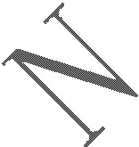

### Contact us:

**Shanghai SIMCom Wireless Solutions Co.,Ltd.**

Address: Building A, SIM Technology Building, No. 633, Jinzhong Road, Shanghai, P. R. China 200335

Tel: +86 21 3252 3300

Fax: +86 21 3252 3020

URL: [www.sim.com/wm](http://www.sim.com/wm)

